1. In RDBMS data will be saved in single database. Sometimes, More than 1 million rows will present in a table. We can improve performance by index, statistics, hints.
2. Sharding is a method of splitting and storing a single logical dataset in multiple databases and rule engine will decide where to store and retrieve the data. Ex: Amazon India/USA Save/Load tables based on region.
3. Sharding is a method of “horizontal” partitioning, meaning that database rows (as opposed to columns i.e Normalization) for a single table are distributed across multiple shards.

**Algorithmic Sharding**

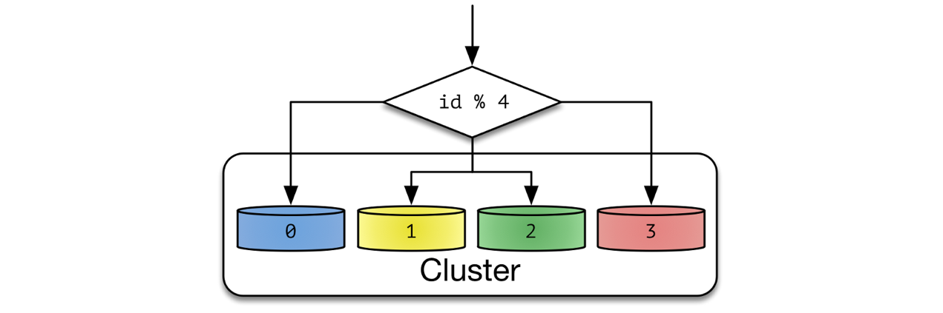

**Dynamic Sharding**

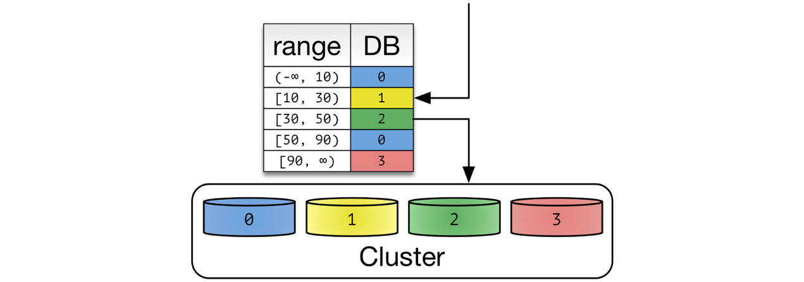

**Entity Groups**

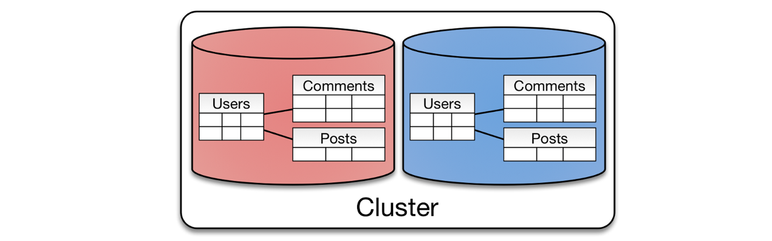

<https://medium.com/@jeeyoungk/how-sharding-works-b4dec46b3f6>